PROCEDURES TO BE CARRIED OUT BY INCOMING MOBILITY STUDENTS

IMPORTANT: This document will be updated periodically, so we advise you not to download it and always check the latest version through the internet link. See the full document online:
You have to follow the procedures that appear in your mobility program. You can save this document and mark the ones that you have already completed.

CHECK THE UJA ACADEMIC CALENDAR

JAÉN CAMPUS MAP

Information of interest about Jaén and Linares
(accommodation urban transport)

IMPORTANT TO ACTIVATE THE GMAIL EMAIL ACCOUNT OF THE UJA, ONCE YOU RECEIVE THE ACCESS CREDENTIALS. See Instructions

 | ERASMUS KA 131 | ERASMUS KA 171 | PLAN PROPIO | SICUE
Before the arrival at UJA
Nomination by Home University.
Pre-registration and Online Registration on UMOVE.
Acceptance letter.

Visa (if applicable)
Medical Insurance valid in the EU
Erasmus+ KA171 grant agreement
Academic Contract (UMOVE)
Enrollment at UJA (Matrícula)
Buddy Program (Mentor Program).
During the stay at UJA
Registration at the International Relations Office. Certificate of arrival.
Welcome day.
Interview with the Academic Coordinator.
Class schedule
Modification of the Academic Contract. (if applicable)
Extension of stay. (if applicable)
Financial Aid for Erasmus+ KA171 students.
Financial Aid for Program students.
After Completing the stay at the UJA
Certificate of Attendance.
Transcript of Records.
Recognition of studies.
Mandatory Final Report for KA107/KA171

In case you need help:

BEFORE ARRIVAL AT UJA.

Nomination by the Home University.

First of all, your university has to send us your nomination, with the necessary information about you and your email address, since that will be the way we will communicate with you. If you do not receive any information from us, please contact your university to check if they have sent us your nomination.
Due to the importance of the nomination process, please make sure that your university submits it correctly. If you encounter any problems during the process, your home university must notify us immediately.
After your nomination, we will contact you by email and provide you with the link to the online application form, the name of the UJA coordinator and other relevant information. Please don't hesitate to ask your host academic coordinator for help.
In the meantime, find complete and detailed information about Jaén and our University on our website (https://www.ujaen.es/internacional/en/international-students/introduction) and read the Guide for international students (https:// www.ujaen.es/internacional/sites/secondlevel_international/files/uploads/documentacion/pdf/internationalguide201819.pdf). You can consult our academic calendar by clicking on this link (https://www.ujaen.es/internacional/en/academics/academic-calendar) and find information about accommodation here (https://www.ujaen.es/internacional/en /international-students/exchange-students).
After your nomination by your home university, we will communicate with you through our system, called UMove. At this stage you will receive a link to the online application form.

Pre-registration and Online Registration on UMOVE.

You will receive a welcome email with instructions on how to register at our University, on the UMOVE platform, by email to the address that your Home University has sent us.
We advise you to carefully read the International Student Guide.

This registration is done through a form that can be accessed from the same mail.

Within the form you can change from Spanish to English whenever you want, by clicking on the corresponding language in the upper right part of the screen.

Once pre-registered, you will receive the access credentials (login and password), which will allow you to access all the functionalities of the UJA virtual campus, as well as student email, which is accessed from the intranet " GMail mail”.

From this moment on, you can manage your mobility by using the UMOVE platform.

Once the student connects, the only option that appears is called My Placement.

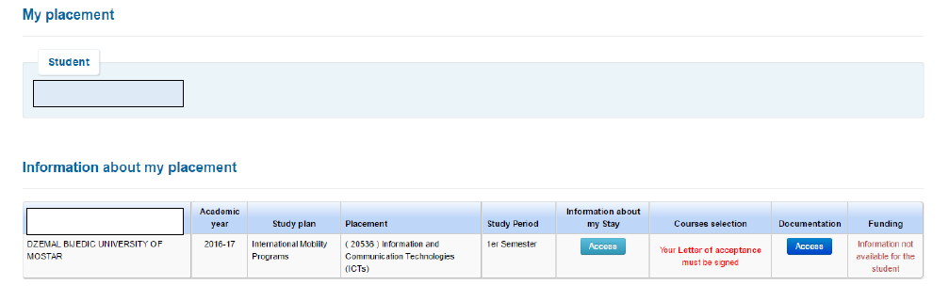

From this screen the student has access to different options:
- Stay: access the management of their stay.
- Selection of subjects: access the selection of the subjects of your contract and you can obtain your mobility contract in PDF. You cannot access it until you have your corresponding acceptance letter signed.
- Documentation: access the list of documentation that can be downloaded or that is necessary for the student to provide.
- Financing (students who receive aid from the University of Jaén): access the details of their financing. You cannot access until you have your corresponding letter of acceptance signed.

Acceptance letter.

You must fill in the information about your stay at UMOVE, and upload the following documents in order to obtain your Letter of Acceptance, if necessary:
- Put the ESTIMATED arrival and departure dates

- ​​Your passport or VALID identity document.
- Certificate of Notes (optional). This document is mandatory for Erasmus+ students KA107-171
- Your medical insurance, which includes civil liability and accidents, as well as repatriation in the event of an accident or death, with coverage for the expenses of a family member. VALID in the EU (in English). This document is not mandatory for SICUE.

Visa

To enter Spanish territory, travelers are required to present a passport or, failing that, an identity or travel document recognized by international agreements, in accordance with the standard criteria of reciprocity. The presentation of the national identity card is sufficient in the case of citizens of the member states of the European Union, Switzerland, Norway, Iceland, and the Principality of Andorra, Monaco and Liechtenstein.
In accordance with the regulations of the European Union, of which Spain is a member state, visitors from a certain number of countries need to have a standard visa, which must be requested at the Spanish Consulate in the applicant's country of residence (http ://www.exteriores.gob.es/ > Embassies and Consulates). Please note that semester international students are normally granted an SSU study visa (Study up to 180 days) and longer staying students are granted an SLU study visa (and, once in Spain , they will have the obligation to request the Authorization to stay for studies in Spain, immediately after their arrival in Jaén, at the Jaén Government Subdelegation - Foreigners Office, Plaza de las Batallas 2, 23007 Jaén 953 999 060). A permanent address is required to be able to request this Authorization to Stay for Studies in Spain.
Students from non-EU countries who wish to study or do research in Spain for a period of more than 3 months must apply for a study visa.
To carry out studies and research for periods lasting less than three months, a student visa is not required, unless the interested party is from a country that requires a visa as standard practice. Keep in mind that sometimes it can take months to complete the process, so as soon as you receive confirmation that you have been selected by your University, contact the Consulate or Embassy of Spain closest to your home. Request information on all the documents you have to present and all the necessary procedures.
To process the student visa, the following documents are needed:
http://www.exteriores.gob.es/Portal/es/ServiciosAlCiudadano/InformacionParaExtranjeros/Paginas/RequisitosDeEntrada.aspx

VALID EU medical insurance.
European Union (EU) students: the European Health Card is valid for all European citizens who spend a period of time in any country of the European Union and Norway, Iceland and Switzerland. Students must contact the authorized agency in their country of origin and apply for the European Health Card. Apart from this, they must take out insurance that compulsorily covers: health care and hospitalization due to accidents and illness (including temporary or permanent disability), and repatriation due to death and illness. Some universities offer this coverage to their students, so you should ask the person responsible for mobility at the university of origin. In addition, we recommend travel assistance insurance.
Students belonging to the SICUE will not be required to have the aforementioned mandatory insurance, since the Spanish Health Card or medical insurance will suffice.
Students from outside the European Union (EU): It is mandatory to take out insurance that must have the following coverage: accidents, illness (including temporary or permanent disability), and death, including repatriation with a companion; in addition to civil liability. Travel assistance coverage is highly recommended (luggage insurance).
Information in the following link: INSURANCE INFORMATION

Once the previous documents have been incorporated, within UMOVE in the 'Documents to download' section, you will be able to download the letter of acceptance, you will also be able to consult the offer of subjects. When the letter is signed, an automatic notice is sent to the student ('acceptance letter notice') indicating that they can download it.

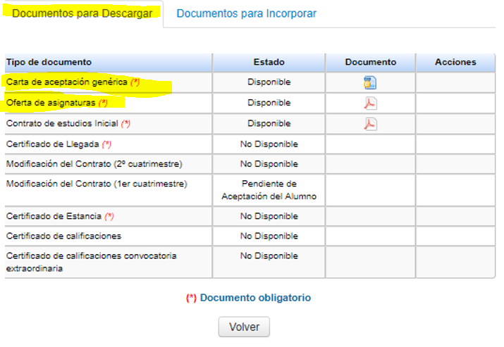
Erasmus + KA 171 grant agreement

ONLY KA 171 PROGRAM WITH ASSOCIATED COUNTRIES OUTSIDE THE EU:
The grant agreement is one of the most important documents, since it sets out the conditions of your grant, as well as the rights and obligations as a grantee. We will inform you, before starting the mobility, when you must sign the document. We advise you to carefully read the 'Help' available in UMove, where you will find the instructions to sign it digitally from the platform. You will also need to sign the 'Addendum to the financial agreement', but this document will be generated for you once you have a Spanish bank account number (after your arrival).

Academic Contract (before mobility).
Please do not need to email your Learning Agreement to the International Office. You have to follow the steps of the different notifications in UMove.
In order to do the learning agreement the first thing that you have to do is to check with your university if they are using Online Agreement OLA.
In the case of Erasmus+ KA131, from universities that use the Online Learning Agreement (OLA) option, a Learning proposal will arrive at our university from your university. It is not necessary to carry out the following steps of the academic contract. Check with your university to see if they are using this option. You should ask them how to do that.
For OLA contracts, the following versions of the Online Learning Agreement (OLA) may be made:
An Initial Contract.
A Modification 1 semester.
A Modification 2 semester.
For all other programmes or Universities that do not use the Online Learning Agreement (OLA) option, you have to follow these instructions.
After you get your Letter of Acceptance digitally signed by UJA, you will be able to view the subjects offered on UMove and start fulfilling your 'Learning Agreement'.
You have to access "My Place" and then click on "Access" in the cell "Learning Agreement", here you can make your Learning Agreement.
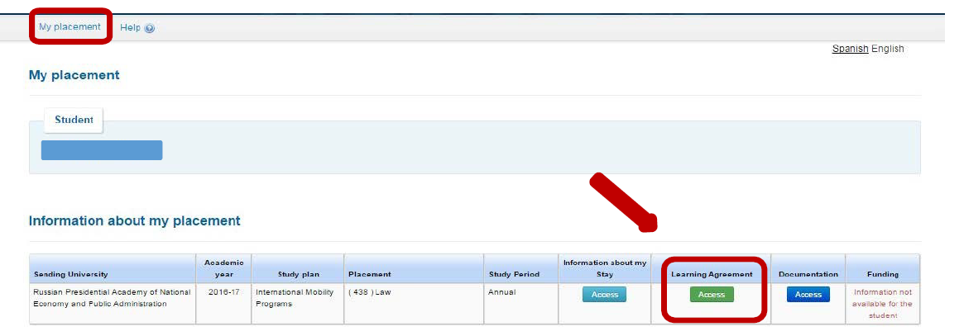

The process to make your Learning Agreement or Mobility Agreement (Form C) begins with the selection of the courses/subjects.
When you get to the 'Learning Agreement' field, click 'Edit' to start editing the learning agreement. The deadline to select courses is in the UMove tool: indicated in “My place”.
The complete offer of subjects is shown below. You can filter by "Language of Instruction" or by "Course Term". . Once you have selected the courses, a counter will show you the total credits and will control the maximum amount of credits that you can include in the 'Learning Agreement'.
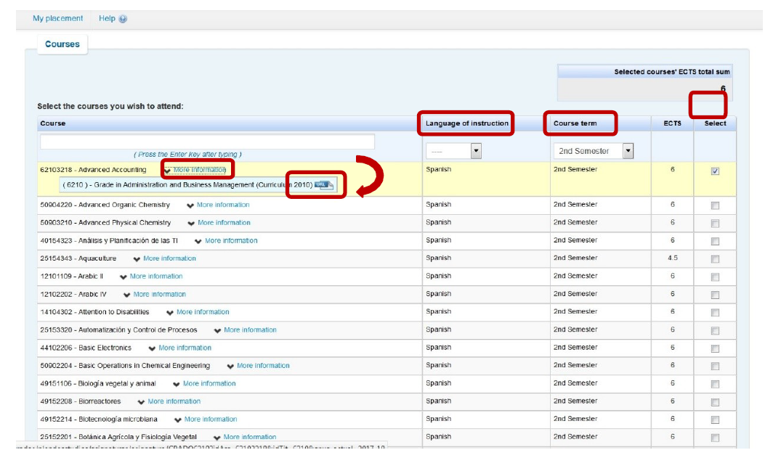

By clicking on the "More information" of each course, a link with more detailed information about the course will be displayed.
Continue filling in the form and click on the different buttons to “Edit”, “Delete” or “Add” other courses. When you have finished presenting all the courses, click "Save". Once you have saved the data, click on “Close” to continue, and then click on “Finish and send your proposal to your UJA Coordinator”.
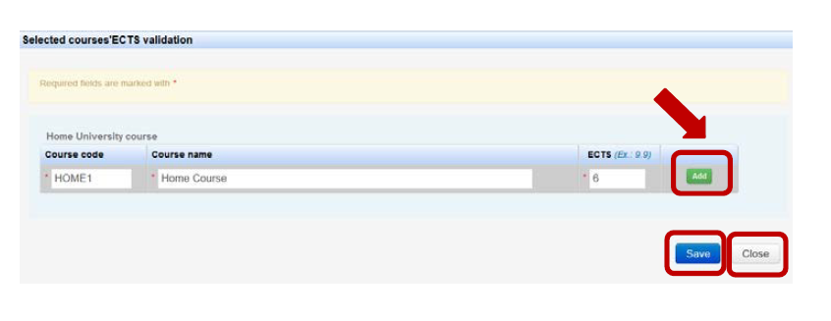
It is important that from this stage on, any communication between you and your coordinator is made through UMove, through the “Communication with the UJA coordinator” button.
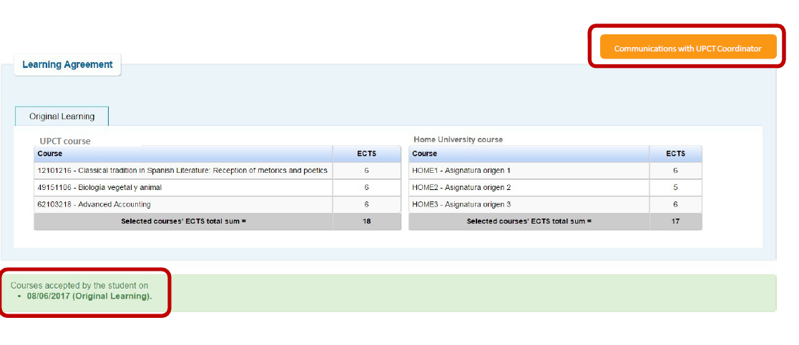

IMPORTANT:
You must use the “Communications with the UJA coordinator to communicate with him and ask about courses, options and any questions you may have. Your coordinator can then accept your communications or suggest some changes. If you suggest that you modify your LA, you may do so IF YOU HAVE NOT CLICKED ON THE “FINISH AND SEND PROPOSAL TO YOUR COORDINATOR” BUTTON (This should be the last step you have to do).
You will receive an email informing you that you have a message in your UMove inbox.
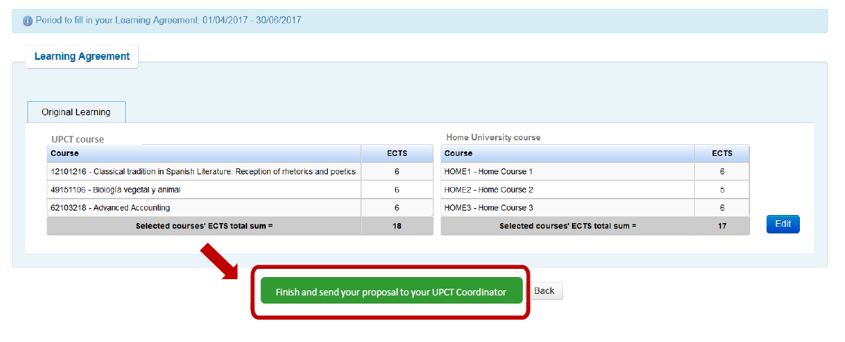

This screen will appear and you will need to send your 'Learning Agreement' proposal to your UJA coordinator. Along with your proposal you must send a message to your coordinator, requesting their acceptance of the proposal. Click "OK" to continue.
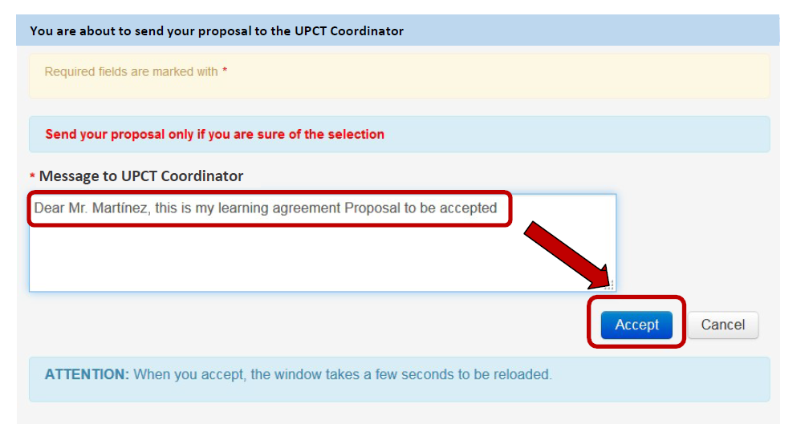

Once you send your proposal to your coordinator, you will not be able to modify your 'Learning Agreement', as this means that both you and your coordinator have already communicated previously and decided on the subjects for that 'Learning Agreement'. Therefore, your proposal should be sent only when both you and your coordinator agree on the courses you will follow.
Access your UMove inbox to check the content of the message (click on the message to read it, it will appear below).

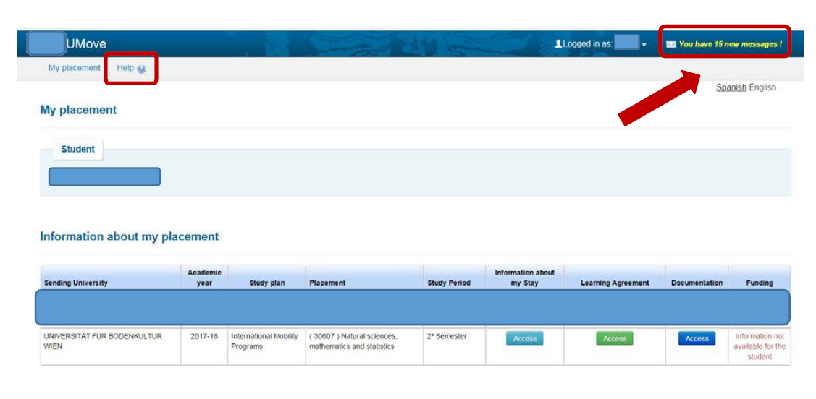

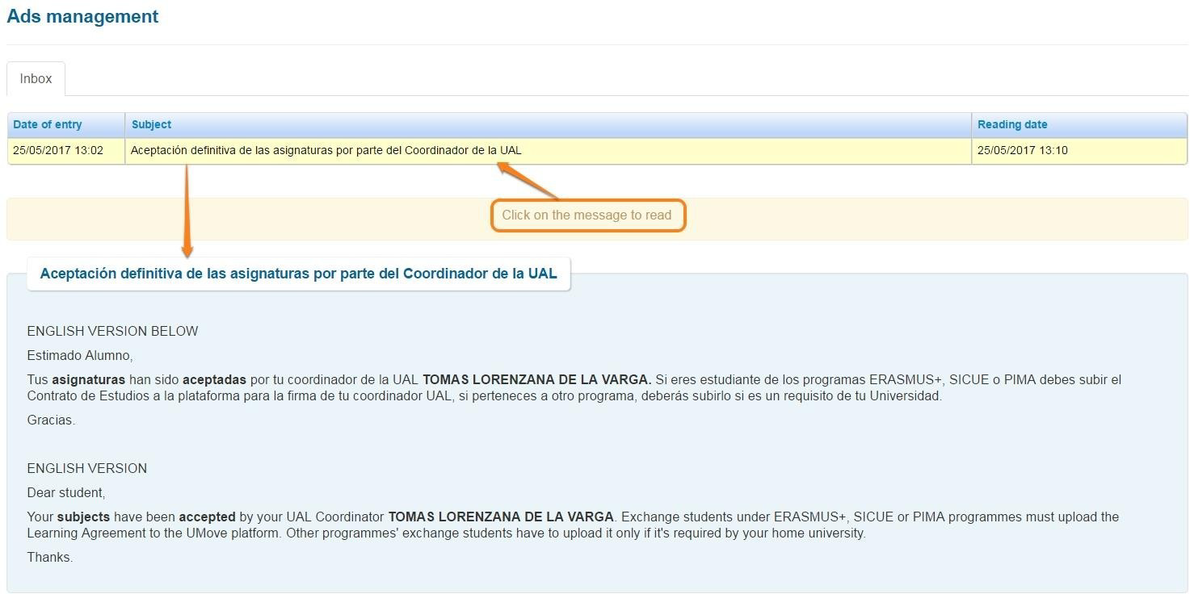

When your coordinator accepts the Learning Agreement proposal, the date of acceptance by your UJA coordinator will be displayed. After this, the document will be available to sign. The generated document is the 'Official Learning Agreement' Model. YOU SHOULD USE THIS TEMPLATE, to the extent possible, to facilitate the process. However, if it is mandatory to use the model provided by the university of origin, you can do so.

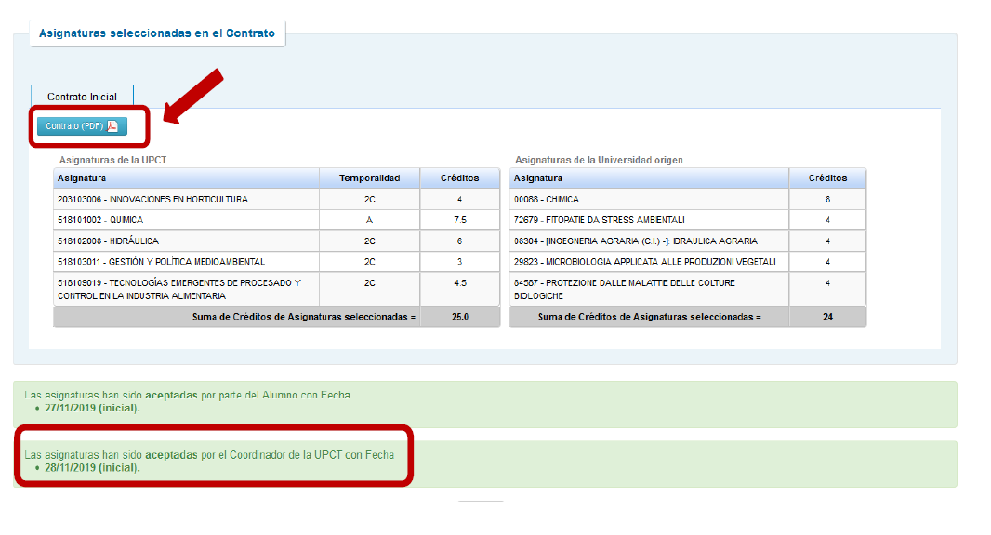

It is very important that, after obtaining the acceptance of the UJA coordinator, the 'Study Agreement' or 'Form C' (see help button in UMove) is signed in this order: the student, the coordinator of origin and, by last, the UJA Coordinator.
To do this,once you sign the 'Learning Agreement', you must download it from UMove and print it so that your home university can also sign it. After your university has signed the document by hand, you must scan it and upload it to UMove, so that your UJA coordinator can digitally sign it and finish the process.
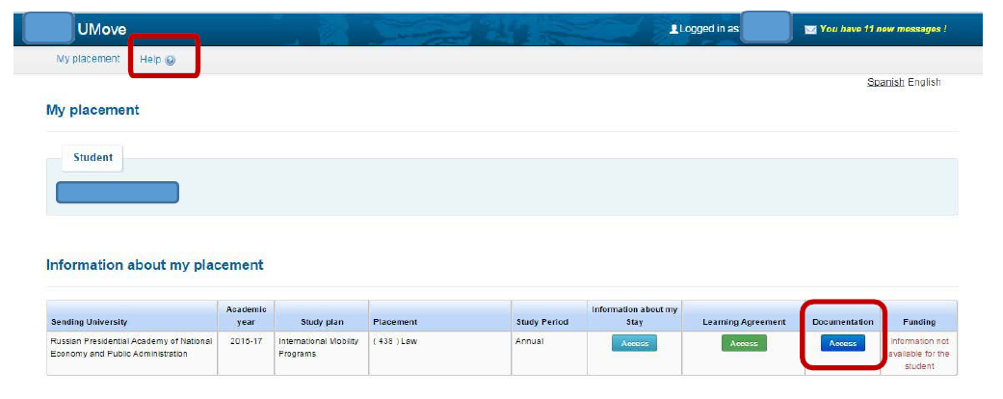

Click on "Documents to Incorporate", and then on the blue button next to the document.
"Learning agreement", which will be shown as "Pending incorporation".

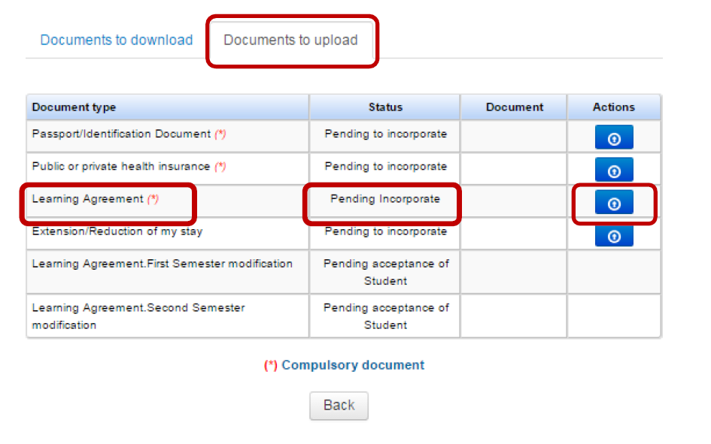
Click "Choose File" to browse for the document on your computer, and once you have it, click "Start Upload" to upload it to UMove.

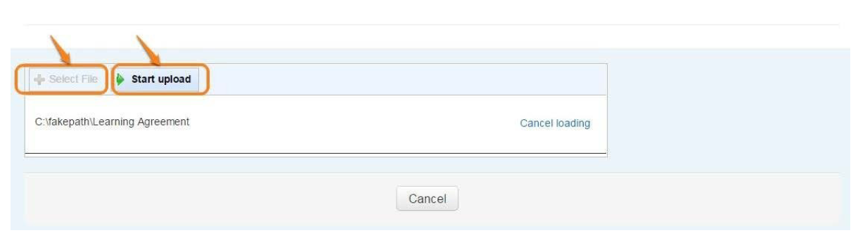

The document will be added to your documentation and will be available for download, once your UJA coordinator has signed it.

ATTENTION: Keep in mind that all documents must be sent and signed online through the UMOVE platform. Any document that can be signed must be uploaded by the student to UMOVE, and, once this is done, the Academic Coordinator will be able to access it and sign it electronically. For this reason, you should not send or request the signature of your documents to the coordinator through a means other than UMOVE (eg, paper or email).

Enrollment at the UJA.

You must complete the Online registration of the subjects that you have in the academic contract. Through the following link: Procedures and Services.

Access to registration (It will be available within the periods established by the regulations of the University of Jaén

Enrollment Tutorial

Mentor Program (Buddy Program).
The main objective of the program is that the international student who comes to the UJA as an exchange student has support from the beginning of their stay through the UJA volunteer mentors, who will guide them and provide help, before their arrival, and during their period. of stay. With this initiative we want to facilitate the cultural, academic and linguistic integration of international students in their new country, city and university.
Enrollment is done through an invitation email that is sent to all international students prior to their arrival.
Link for registration.

Note: this program is not for SICUE students.

SEE HOW IT WORKS
DURING YOUR STAY IN LA UJA.

Registration at the International Relations Office. Certificate of incorporation or arrival.

When you arrive at the University of Jaén, you must present yourself at the International Relations Section (Universidad de Jaén, International Relations Section, C2-105)) or at the Linares Scientific and Technological Campus, for the processing of your incorporation certificate. The opening hours are from Monday to Friday from 09:00 to 14:00.

Then you must wait a few days to receive your 'Certificate of Incorporation'. The document will appear in UMove, digitally signed, and you can download and print it anytime you need it.

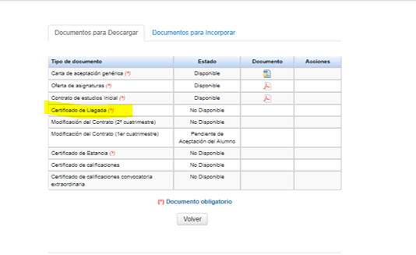

However, if you are required to use the model provided by your university, you can bring it to the IR office.

Interview with the Academic Coordinator of the UJA.

The Academic Coordinator is the professor at the University of Jaén with whom you can consult on any matter regarding the development of your studies during your stay. You can find your name and email address in the “STAY” section of UMOVE, however, in the International Relations Section we can also provide you with the data, if you do not have it.
It is especially important that you have a first interview with him to introduce yourself and to review the subjects included in your academic contract in case you have to make changes.
coordinators SICUE:
https://docs.google.com/viewer?url=https%3A%2F%2Fwww.ujaen.es%2Finternacional%2Fsites%2Fsegundonivel_internacional%2Ffiles%2Fuploads%2Fconvocatoria_internacional%2F2023-02%2FREGAGE23e00007808249%2520%25282%2529.pdf

Class schedule.
Your academic coordinator will make it easy for you to find class schedules. If this is not possible, we will indicate how to access it:

Information on the subjects available at the University of Jaén is available at the following links.

- Teaching guides
https://uvirtual.ujaen.es/pub/es/informacionacademica/catalogoguiasdocentes/p/2023-24

- The schedules are also available on the website of each faculty.
https://www.ujaen.es/centros

- Consult subjects taught in other languages ​​(English, French or German):

https://uvirtual.ujaen.es/pub/es/informacionacademica/catalogoguiasdocentes/p/patie

Welcome Days.

At the beginning of the academic year, the orientation Welcome Day will be held: the Vice-rector for Internationalization (and the rest of the members of the international team) will welcome all the mobility students during the so-called 'Welcome Day' (once the classes have started). Students will be invited to participate in this conference by email and during this session they will receive complete information about the academic and non-academic activities of the UJA.

How to change the Learning Agreement? (During the mobility)
At the beginning of each semester you will have a period of five weeks to propose changes in your study contract and, subsequently, in your enrollment. Please agree to the changes with your Originating Coordinator before entering them in Umove. Both the contract modification and the registration modification will be carried out in the same way as the initial contract and registration. Don't worry: we will notify you of the start and end of all deadlines.

Important!
- If you don't have your signed Confirmation of Arrival in UMove, you won't be able to change your Learning Agreement!
- You can change your Learning Agreement ONLY ONCE! Therefore, before making any changes, make sure you make the right decision.

How to update the registration?
Once the changes in the Learning Agreement are approved by your UJA Coordinator, we will give you a personalized term to change your Enrollment, according to the changes in your contract. The registration modification will be carried out in the same way as the initial registration. Don't worry, we will notify you of the start and end of all deadlines.

Extension of Stay [Except Erasmus+ KA107-171]

First semester students can request an extension of stay at the University of Jaén to continue their studies during the second semester.

If you are interested in requesting an extension of your stay, you must pick up the application form for an extension of your stay at the International Relations Section of the University of Jaén, available at: https://www.ujaen.es/internacional/introduccion/impresos-y -applications
For SICUE students, the extension model can be found in Form C, page 3:
https://www.ujaen.es/internacional/introduccion/impresos-y-solicitudes

The extension of the stay will be effective when the University of origin confirms that you agree with your request for an extension of your stay.

Once the request for an extension of stay has been approved, the student will be able to modify their academic contract and their registration to add second-semester subjects.

Financial Aid for students of the Erasmus+ KA 171
. Students of this program will receive 70% of the amount of their financial aid, as well as the amount of the contribution to the trip upon arrival at the UJA, and after visiting the Relations Office International. Both the 'Learning Agreement', the 'Grant Agreement' and the 'Addendum to the Grant Agreement' must be signed and uploaded to UMOVE before this payment.
Then a second payment of 30% will be made after 105 days. It is mandatory to complete the entire period of stay and the final survey or the aid may be claimed.

ATTENTION: the conditions previously described are indicative, they could be altered. In any case, the conditions established in the Grant Agreement document signed by the student and the University of Jaén will be followed.

It will be essential to have a Spanish bank account for this payment. We recommend that you start the procedure to open your Spanish bank account from your country as soon as possible.
We recommend that you start the process to open your Spanish bank account from your country as soon as possible, in this way easier for it to be opened more quickly upon arrival and thus you will be able to collect your scholarship as soon as possible. In general, all resident and non-resident foreigners who require the opening of a bank account must present:
- Valid passport.
- A photography.
- TIN: Tax Identification Number of the country of origin.
- NIE (Foreigner Identification Number) or Negative Certification of Residence.
We recommend that when you go to apply for your visa, you indicate that you need a NIE number to open your bank account in Spain. In case you do not have a NIE number on your visa, some banks can help you manage it once you are in Jaén. In that case, you will likely be charged a handling fee for the procedure.

AFTER FINISHING THE STAY IN LA UJA.

Certificate of Completion of Stay.
Certificate of Attendance.

The Certificate of Completion of Stay is a very important document, since it is the one that serves to prove to your University of origin the full duration of the stay you have made.

To obtain this Certificate of Completion of Stay you must go to the international relations office to register the day of the end of the stay (University of Jaén, International Relations Section, C2-105, 23071 Jaén) or at the Scientific and Technological Campus de Linares for the processing of your certificate of completion, once signed you can download it from UMOVE, section “Documents to download”.
The end date will be the last day you go through RRII, in no case will the stay be signed with another date. In order to process the TOR, it is a mandatory requirement that you go to the office to certify your departure
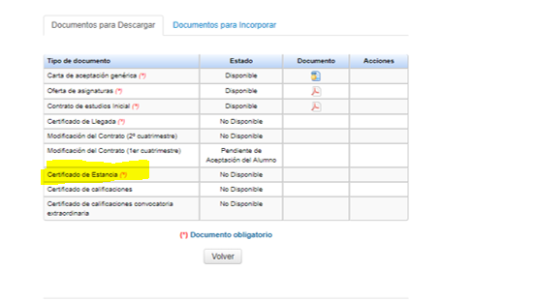
. If you have a model from your university, you can bring it to the office on the day of departure so that we can sign it.

Certificate of Notes of Records.

Once your Erasmus+ International or SICUE stay is over, the University of Jaén will issue a Transcript of Records to all those students who:
- Have no pending procedures related to their Academic Contract.
- have been successfully enrolled.
- They have officially notified the end of their stay.
- That all the subjects in which you are enrolled have been definitively graded, that is, that the exam review period has expired.
As the rest of your documentation will be available in Umove, we will also send an email to your University at the end of your stay.

The Transcript of Records will only collect grades for subjects in which the student has been officially enrolled.
The University of Jaén will send this certificate by email to your home university in the following approximate periods:
- First semester students: End of February.
- Second semester and full course students: Beginning of August.
- Postgraduate students: September/October.

The Transcript of Records, once signed, can be downloaded from UMOVE, section “Documents to download”.
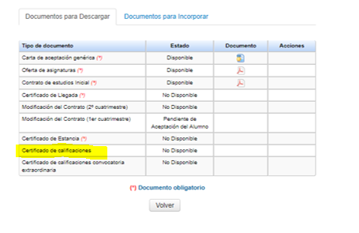

Recognition of studies.
For the students of the Erasmus+ KA 171 program, once they have finished their stay and as soon as their Universities have recognized the studies carried out at the UJA, they are obliged by the financial agreement to upload to Umove a document issued by their University of origin to effect, which can also be an academic certificate, where it is clearly justified that all the grades passed at the UJA have been transferred to their academic record.
Don't forget to upload it to UMove when your University provides it to you. At that time, your obligations with the UJA regarding your mobility will have ended.

Compulsory Final Report for KA107/KA171
Erasmus + mobility students must make a Final Report of their stay through the EU platform, whose communication they will receive through the student's email, on the scheduled end date of their mobility.

Information of Interest JAEN/LINARES:

Information of Interest JAEN/LINARES:

JAEN
- Dominic Savio Hall of Residence. Jaen University.  - University Apartments.  Web: http://www.alojamientosuja.com/  - Hostel Network.  - Residences and Hotels in Jaén:  - Tourist Office of the City Council of Jaén. | AIRPORT FEDERICO GARCÍA-LORCA GRANADA-JAÉN  Tfn.: 958 24 52 00.  www.aena.es  BUS STATION  Plaza de la Libertad, s/n  Tfn.: 953 23 23 00  www.epassa.es/autobus  ADIF TRAIN STATION  Pl. Jaén for Peace, s/n  Tfn.: 902 24 02 02.  www.renfe.es | Urban Transport in Jaén  Citizen Information Office. C/ Carrera de Jesús. Hours: 9.00-14.00.  Telephone: 900 72 72 73.  More detailed information of the lines:  https://www.transporteurbanodejaen.es/  TeleTaxi: 953 27 10 10  RadioTaxi: 953 22 22 22
LINARES
- Linares Tourism Office. | ADIF LINARES BAEZA TRAIN STATION | Urban Transport Linares  Taxi in Linares

LINES OF URBAN TRANSPORTATION IN JAEN
The lines that have a stop at the University or in the vicinity are the following:
- Línea 4: Alcantarilla-Universidad-Centro Comercial (Horarios Linea 4)
- Línea 7: Circular Plaza Libertad (Horarios Línea 7)
- Línea 14: Ben Saprut- Carrefour (Horarios Línea 14)
- Línea 17: Circular C Hospitalario (Horarios Línea 17)
- Línea 20: Circular España 57 (Horarios Linea 20)
- Línea 21: Millan de Priego-Universidad- Hospital (Horarios Línea 21)
- M7: Mercadillo Circular Ben Saprut
- Línea 11: C.Hospitalario-Plaza Libertad (paradas en Carretera de Madrid)

You can check their stops and route in the links of each line. However, on the official website you can check your best route through a personalized search:https://www.transporteurbanodejaen.es/mejor-trayecto

You can request the bus pass following the procedures established in:https://sede.aytojaen.es/sta/CarpetaPublic/doEvent?APP_CODE=STA&PAGE_CODE=CATALOGO&DETALLE=6269026833971888405011

